Charmed Table Runner
Dianne Barnden
Finished size – 36” x 20”

Note
This is an ideal project to dive into your stash and pull some coordinating fabrics out. This table runner really lends itself to a scrap look. You could also use a packet of charm squares and cut them horizontally and vertically to give you the 2½” squares required.

Needs List
FABRIC
- 48 2½” squares (if you are using charm squares you will need 12 5” charm squares)
- .2 metre fabric for inner border
- .4 metre fabric for outer border
- .4 metre of fabric for binding.
- .6 metre of fabric for backing
- .6 metre of batting

EQUIPMENT
- Sewing machine, manual and usual sewing supplies.
- Rotary Cutter.
- Cutting Mat.
- Rulers.

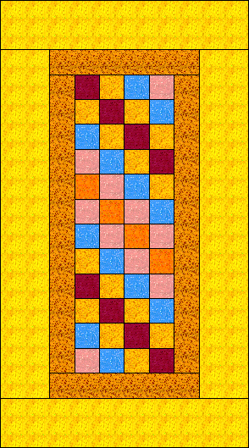
Pinwheel Stars
Dianne Barnden
Finished size – 32½” x 14 ½” (table runner)
Note
The stars are based on a scrappy look. Each star contains 3 different colours and ideally you will pull fabrics from your stash or scrap bin. I have included yardage for the stars but it is a small amount.

Needs List (Colours are based on the Sample)
FABRIC
Background (grey)
.4 metre
Stars & Sashing
.2 metre (star points)
.2 metre (centre pinwheel)
.2 metre (centre pinwheel)
Binding
.3 metre (grey)
EQUIPMENT
- Sewing machine, manual and usual sewing supplies.
- Rotary Cutter.
- Cutting Mat.
- pencil
- Rulers.

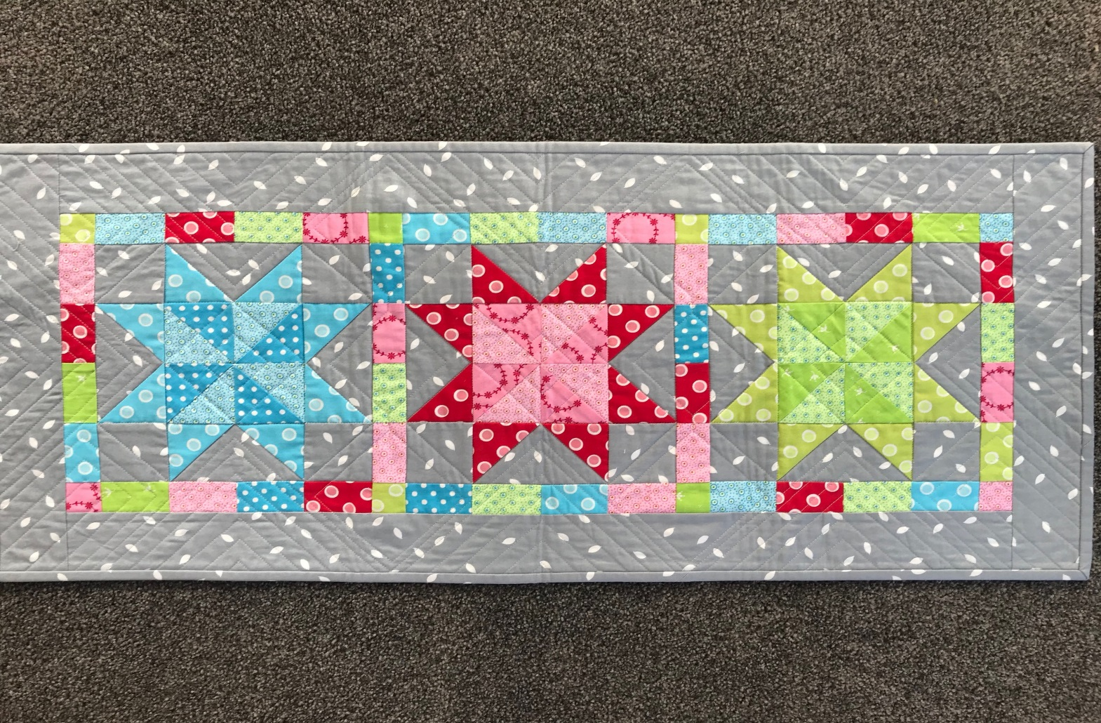
Dizzy for Dresden
Dianne Barnden
Finished size – 45½” x 18½” (Table runner)
Note
Each plate is made up of 20 wedges. The fabric requirement is dependent on the look you want. In my sample each plate has 7 different fabrics. There are a total of 60 wedges for 3 Dresden plates.
A cut of .2 metre will yield you 16 wedges, if you want plates containing only one fabric you will need to purchase .4 per plate. For a scrappy look you will need to purchase a variety of .2 metre cuts. Each plate on the sample has 7 different fabrics.
Needs List
Fabric Requirements
Background fabric
1 metre
Dresden plates
A variety of .2 metre cuts for a scrappy look, the amount of cuts (fabric) depends on how many fabrics you want in your plate.
Or
.8 metre if you want all your plates to be the same
or
.4 metre of 3 different fabrics if you want each of your plates to contain the same fabrics. (there will be left over fabric here as each wedge requires 20 wedges and .2 will only give you 16 wedges)
Binding Fabric
.4 metre
Backing fabric
1.3 metre (if you do not want a join)

- Sewing machine, manual and usual sewing supplies.
- Rotary Cutter.
- Cutting Mat.
- Rulers
  - Long ruler for cutting wof strips
  - Darlene Zimmerman Easy Dresden Acrylic Tool
EZ Dresden Ruler. This is the one by Darlene Zimmerman. This ruler will make Dresden blades from 1 inch to 8 inches. This particular ruler requires 20 blades to make a full plate.

