BEGINNERS SEWING
FABRIC GUIDELINES  Bag Outer  - WOVEN Non -Stretch fabric.  - Furnishing weight fabric is suitable for the outer bag. (Dress or Shirt weight fabrics are too lightweight).  - Cotton, cotton rich (more than 50% Cotton) or Linen, fabrics are recommended for easier handling.  - AVOID fabrics that are thick, loosely woven, too stiff or ‘boardy’  Bag Inner Lining (NOT garment lining fabric)  Cotton – shirt or dress weight is recommended  Recommended: Cotton Broadcloth (this is available in a variety of colours from Spotlight or equivalent.  Recommended: Fabrics may be pre-shrunk by short machine washing in warm/hot water and hot tumble dried and pressed, prior to class. Check with retailers care instructions prior to washing | 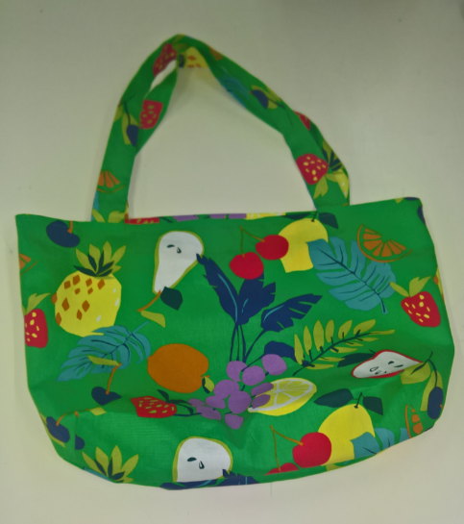
 | 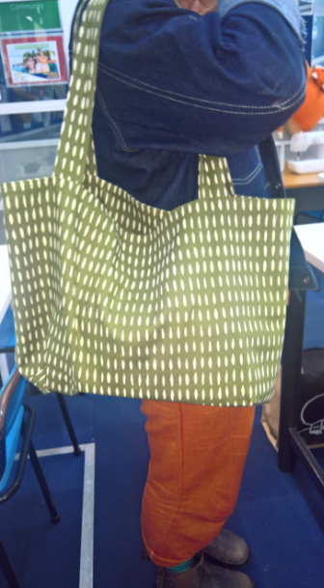
Purchase:
1 metre of Bag Outer Fabric (minimum width 115 cm)*
1 metre of Inner Lining Fabric (minimum width 115 cm)*
1 x Bag Outer matching polyester thread
1x 15 cm dress zip (matched to lining or may be contrast). NOT an Invisible zip.
*Extra may be required for One-Way (where a fabric motif is read only one way) design prints
Reminder to also bring:
- Pins – plain pins. The ‘fancy’ ones with plastic tops are usually very poor quality.
- Tape measure
- Scissors/Shears (there are scissors in class you may use). An excellent value pair of fabric scissors is available from Pete’s Emporium (Porirua) for great price of $25
- Matching Thread(s) to fabric colour
- Snips (optional)
- Tailors Chalk
- Pen & Notepaper

